**Hyperparameter Tuning for Renewal + LexisNexis with Sample_Weight**

| **Params** | **A_Tr** | **P_Tr** | **R_Tr** | **f1_Tr** | **A_Val** | **P_Val** | **R_Val** | **f1_Val** | **Min_Max** |
| --- | --- | --- | --- | --- | --- | --- | --- | --- | --- |
| L1 - 0, 0.1  L2 - 10  lr - 0.3 | 0.62 | 0.39 | 0.80 | 0.52 | 0.57 | 0.33 | 0.67 | 0.45 | 9-89 (D) |
| L1 - 0  L2 - 10  lr - 0.025 | 0.75 | 0.57 | 0.22 | 0.32 | 0.72 | 0.40 | 0.14 | 0.21 | 30-59 |
| L1 - 0  L2 - 10  lr - 0.015 | 0.75 | 0.55 | 0.22 | 0.32 | 0.72 | 0.42 | 0.15 | 0.22 | 41-54 |
| L1 - 0  L2 - 10  lr - 0.2 | 0.76 | 0.56 | 0.34 | 0.43 | 0.70 | 0.39 | 0.24 | 0.30 | 12-74 |
| L1 - 0.1  L2 - 10  lr - 0.025 | 0.75 | 0.57 | 0.22 | 0.31 | 0.72 | 0.40 | 0.14 | 0.21 | 30-59 |
| L1 - 0.3  L2 - 10  lr - 0.025 | 0.75 | 0.57 | 0.21 | 0.31 | 0.71 | 0.38 | 0.13 | 0.20 | 30-59 |
| L1 - 1  L2 - 10  lr - 0.025 | 0.75 | 0.56 | 0.21 | 0.31 | 0.71 | 0.34 | 0.12 | 0.18 | 31-59 |
| L1 - 10  L2 - 10  lr - 0.025 | 0.56 | 0.35 | 0.79 | 0.48 | 0.53 | 0.31 | 0.70 | 0.43 | 36-64 |
| L1 - 50  L2 - 10  lr - 0.025 | 0.41 | 0.29 | 0.92 | 0.44 | 0.39 | 0.28 | 0.91 | 0.43 | 47-57 |
| L1 - 100  L2 - 10  lr - 0.025 | 0.73 | 0 | 0 | 0 | 0.74 | 0 | 0 | 0 | 41-50 |
| L1 - 0  L2 - 1  lr - 0.3 | 0.64 | 0.40 | 0.81 | 0.54 | 0.58 | 0.34 | 0.69 | 0.46 | 5-93 (D) |
| L1 - 0  L2 - 30  lr - 0.3 | 0.76 | 0.55 | 0.39 | 0.46 | 0.69 | 0.35 | 0.22 | 0.27 | 12-79 |
| L1 - 0  L2 - 50  lr - 0.3 | 0.76 | 0.58 | 0.38 | 0.46 | 0.70 | 0.38 | 0.23 | 0.29 | 14-76 |
| L1 - 0  L2 - 100  lr - 0.3 | 0.76 | 0.58 | 0.37 | 0.45 | 0.71 | 0.41 | 0.24 | 0.30 | 13-75 |
| L1 - 0  L2 - 0.5  lr - 0.3 | 0.77 | 0.59 | 0.42 | 0.49 | 0.71 | 0.41 | 0.28 | 0.34 | 5-91 (D) |
| L1 - 0  L2 - 0.1  lr - 0.3 | 0.74 | 0.52 | 0.43 | 0.47 | 0.69 | 0.35 | 0.23 | 0.28 | 3-95 (D) |
| L1 - 0  L2 - 0.01  lr - 0.3 | 0.57 | 0.35 | 0.79 | 0.49 | 0.53 | 0.32 | 0.71 | 0.44 | 18-79 |
| L1 - 0  L2 - 0.08  lr - 0.3 | 0.74 | 0.51 | 0.43 | 0.47 | 0.69 | 0.35 | 0.23 | 0.28 | 3-95 (D)  Decile same as 2nd above |
| L1 - 0  L2 - 0.05  lr - 0.3 | 0.77 | 0.59 | 0.43 | 0.50 | 0.69 | 0.37 | 0.24 | 0.29 | 6-87 (D) |
|  |  |  |  |  |  |  |  |  |  |
|  |  |  |  |  |  |  |  |  |  |
|  |  |  |  |  |  |  |  |  |  |

**L1 - 0, L2 - 10, lr - 0.3 (Train)**

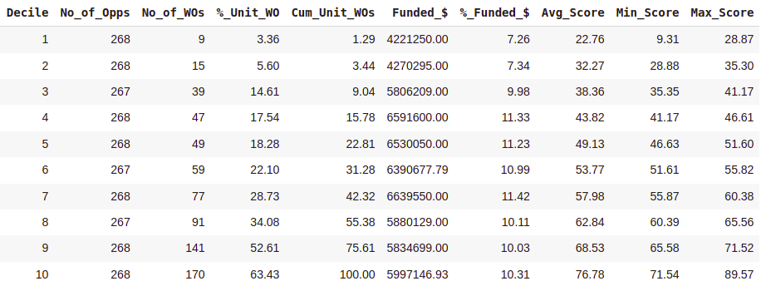

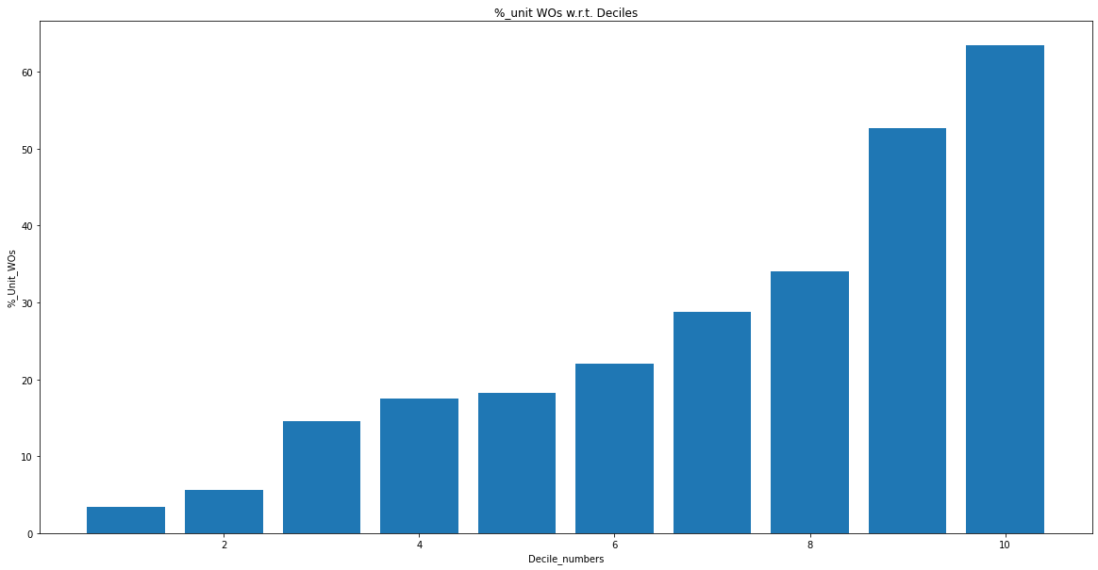

**L1 - 0, L2 - 10, lr - 0.3 (Test)**

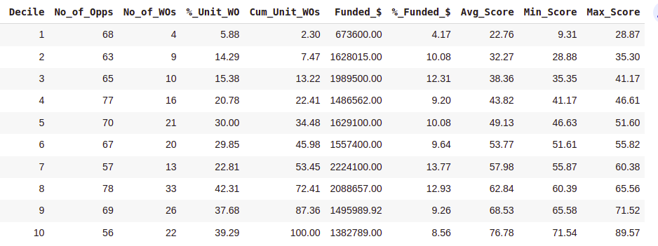

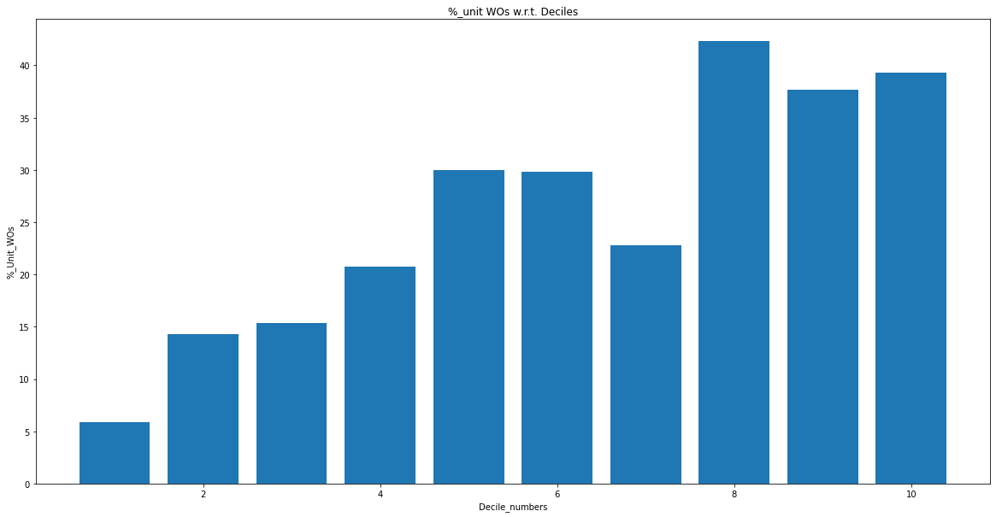

**L1 - 0, L2 - 1, lr - 0.3 (Train)**

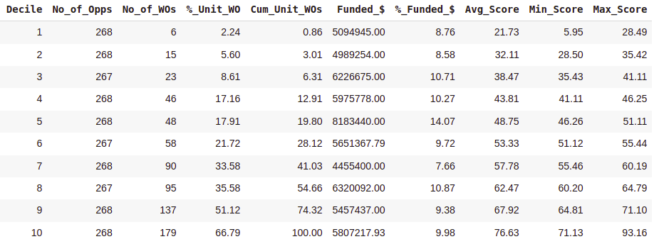

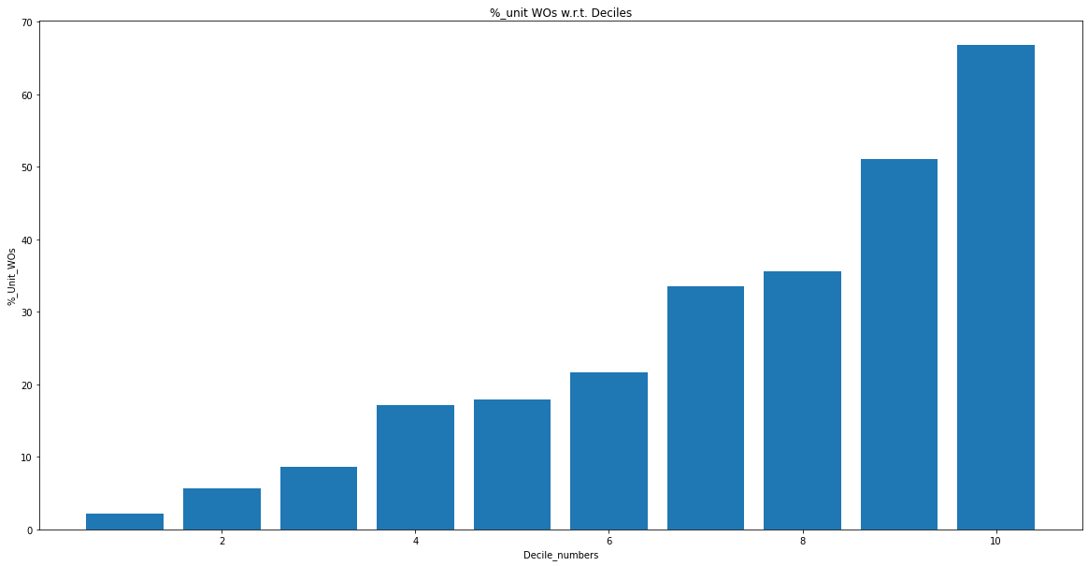

**L1 - 0, L2 - 1, lr - 0.3 (Test)**

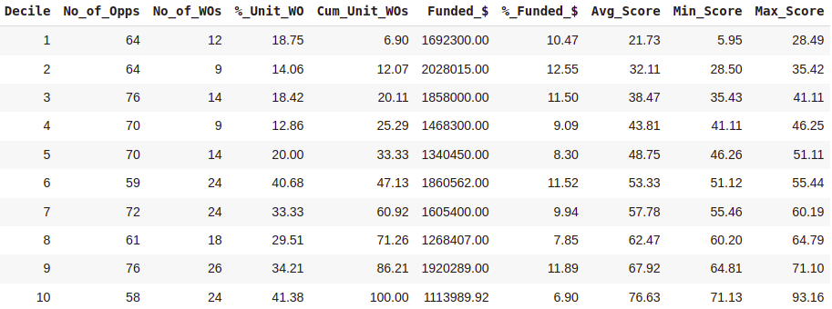

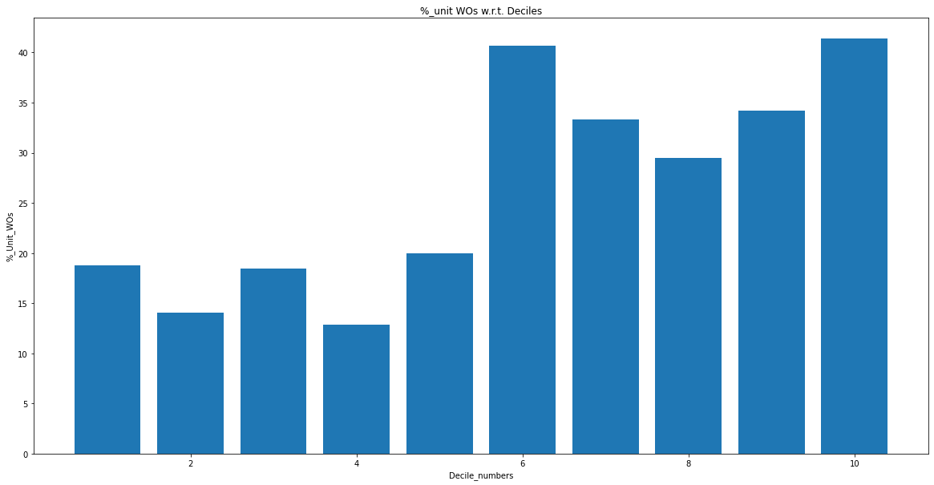

**L1 - 0, L2 - 0.1, lr - 0.3 (Train)**

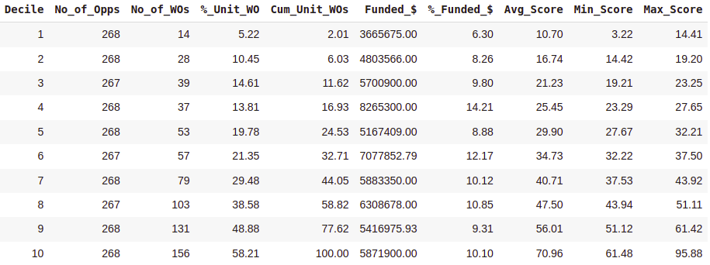

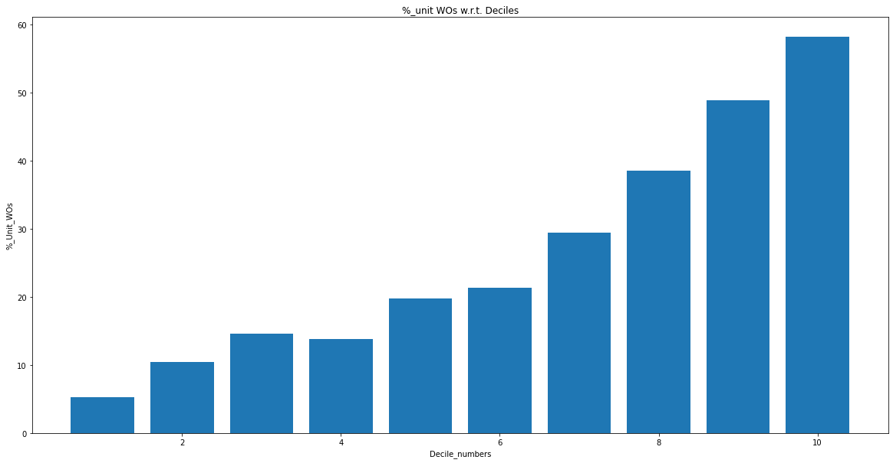

**L1 - 0, L2 - 0.1, lr - 0.3 (Test)**

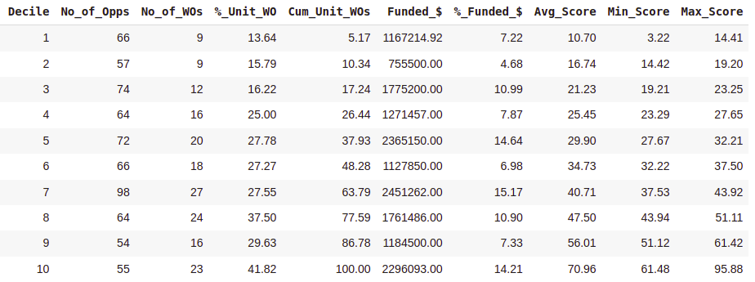

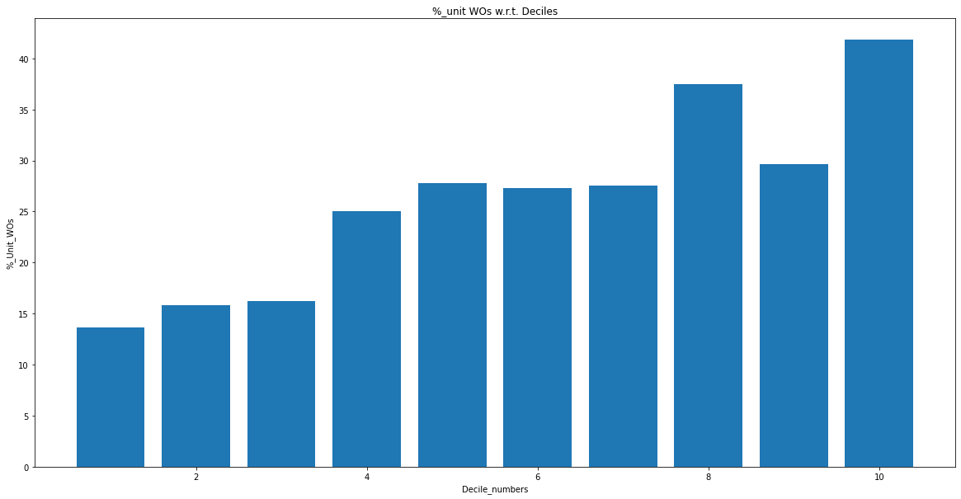

**L1 - 0, L2 - 0.5, lr - 0.3 (Train)**

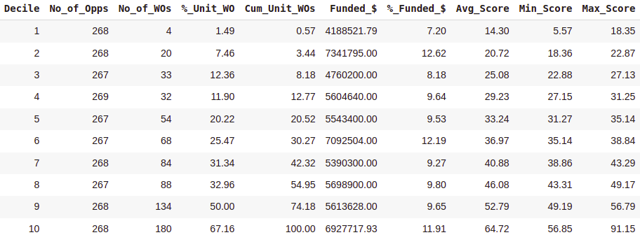

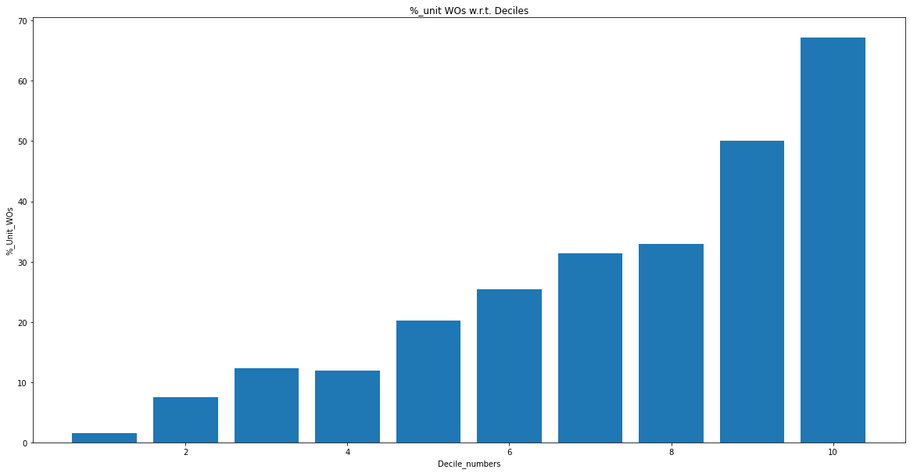

**L1 - 0, L2 - 0.5, lr - 0.3 (Test)**

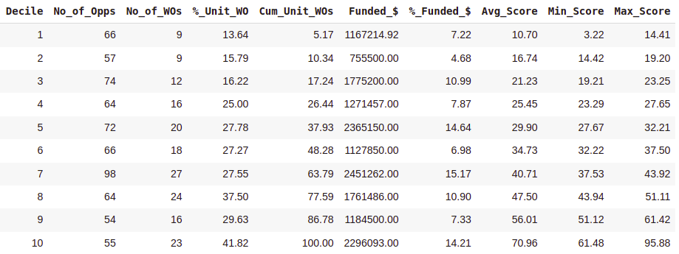



**L1 - 0, L2 - 0.05, lr - 0.3 (Train)**

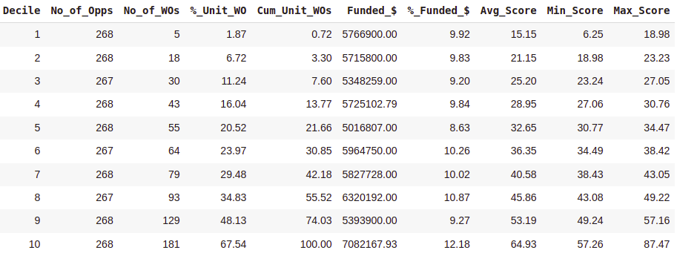

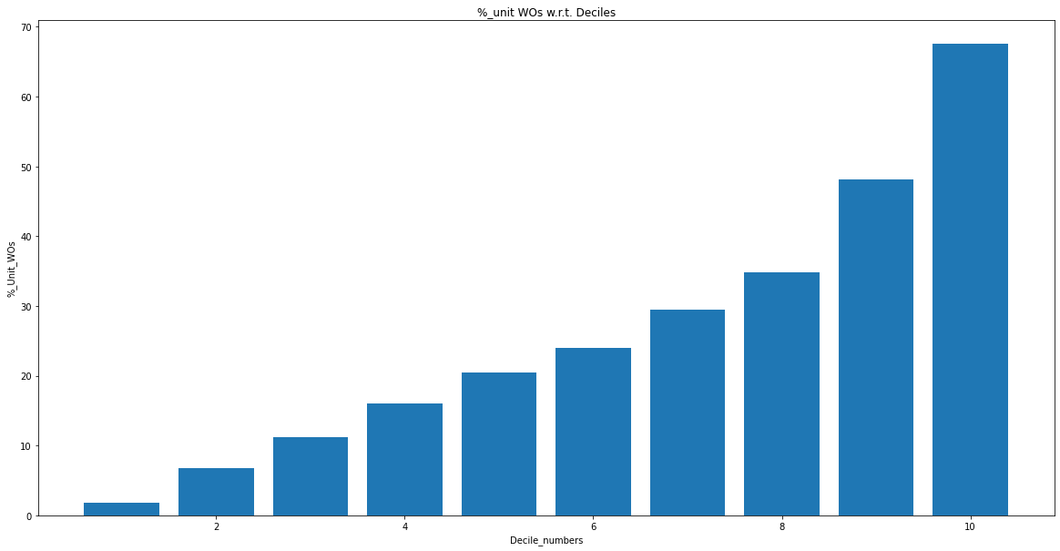

**L1 - 0, L2 - 0.05, lr - 0.3 (Test)**

